**Institute of Information Technology (IIT)**

Jahangirnagar University



**Lab Report: 01**

Submitted by:

Name: Md. Shakil Hossain  
Roll No: 192340

Lab Date: 23/05/2023  
Submission Date: 29/05/2023

**Lab Report # Day 01**

**Example 1:**

Knowledge Base 1.

**Clause:**

*woman(mia).*

*woman(jody).*

*woman(yolanda).*

*playsAirGuitar(jody).*

*party.*

**Queries:**

?- woman(mia).

?- playsAirGuitar(jody).

?- playsAirGuitar(mia).

?- tattoed(jody).

?- party.

?- rockConcert.

**Result:**

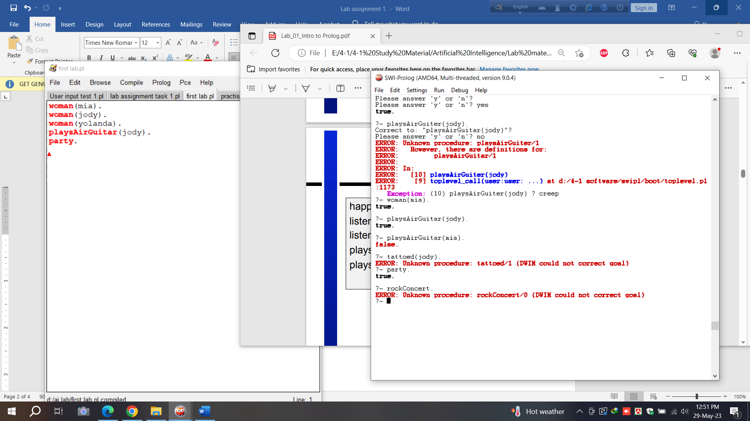

**Example 2:**

Knowledge Base 2.

**Clause:**

*happy(yolanda).*

*listens2music(mia).*

*listens2music(yolanda):- happy(yolanda).*

*playsAirGuitar(mia):- listens2music(mia).*

*playsAirGuitar(yolanda):- listens2music(yolanda).*

**Queries:**

?- playsAirGuitar(mia).

?- playsAirGuitar(yolanda).

**Result:**

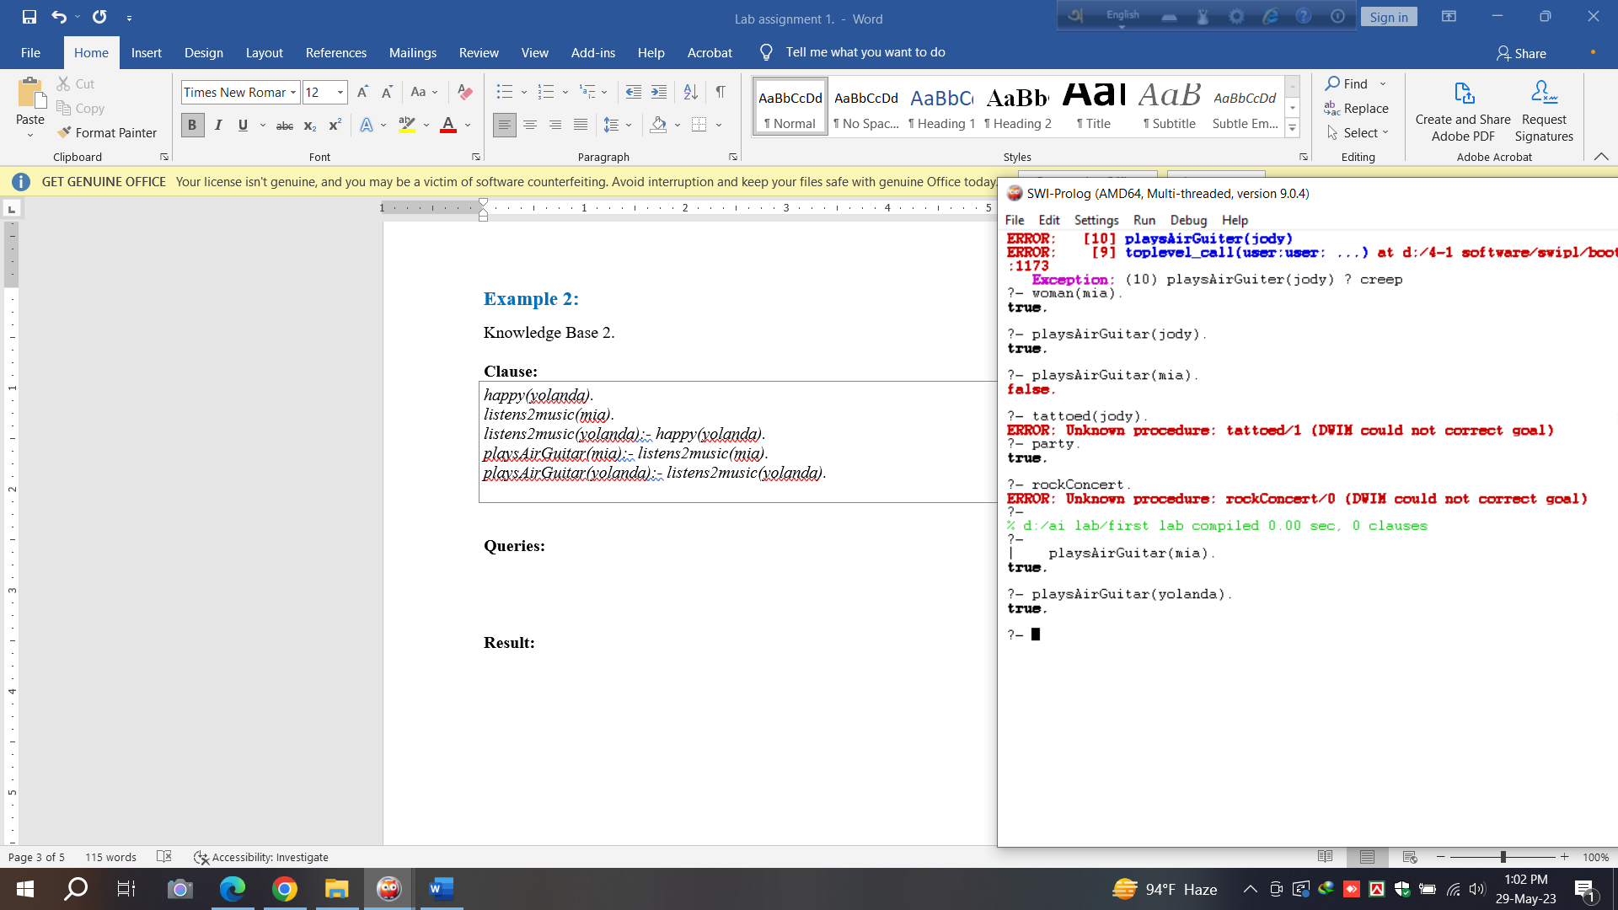

**Example 3:**

Knowledge Base 3.

**Clause:**

*happy(vincent).*

*listens2music(butch).*

*playsAirGuitar(vincent):- listens2music(vincent), happy(vincent).*

*playsAirGuitar(butch):- happy(butch).*

*playsAirGuitar(butch):- listens2music(butch).*

**Queries:**

?- playsAirGuitar(vincent).

?- playsAirGuitar(butch).

**Result:**

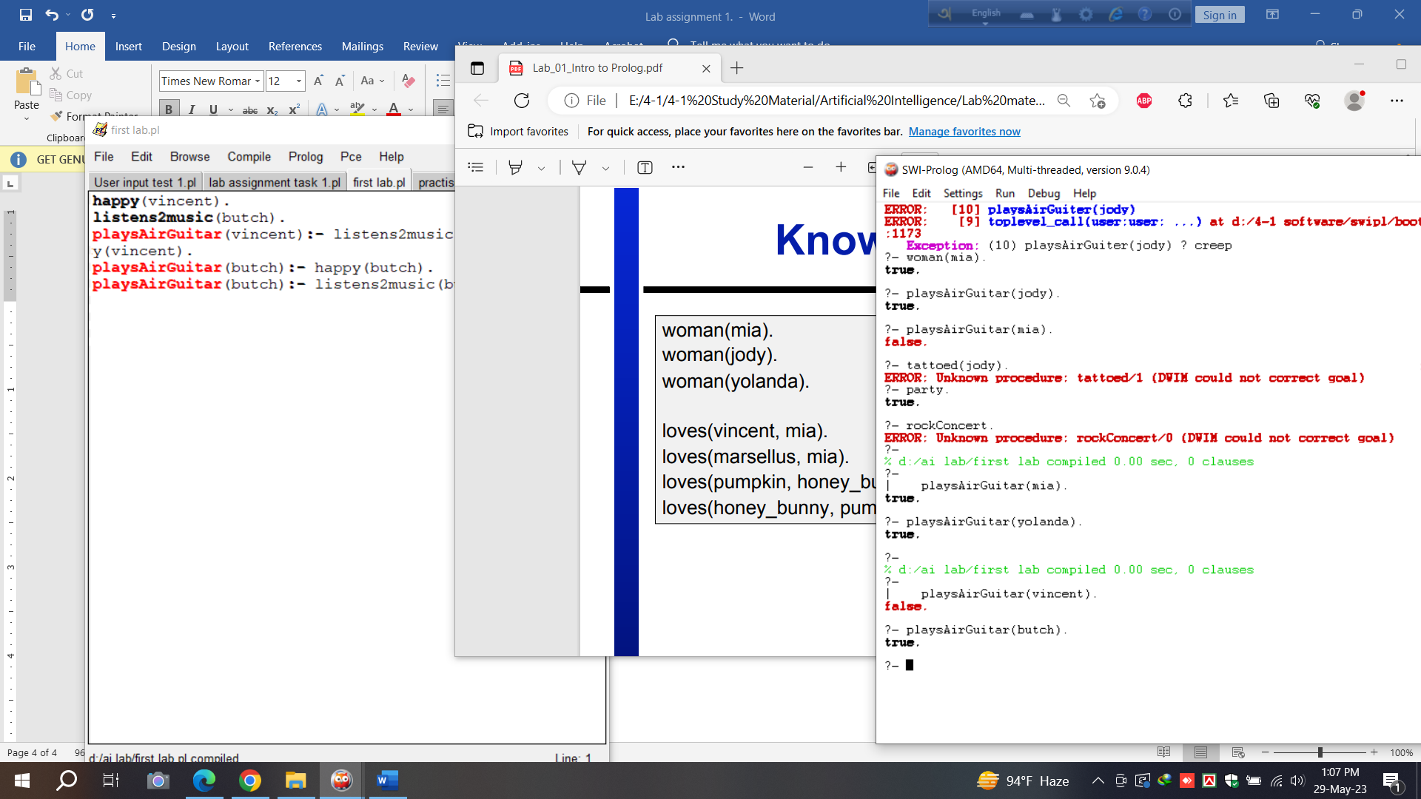

**Example 4:**

Knowledge Base 4.

**Clause:**

*woman(mia).*

*woman(jody).*

*woman(yolanda).*

*loves(vincent, mia).*

*loves(marsellus, mia).*

*loves(pumpkin, honey_bunny).*

*loves(honey_bunny, pumpkin).*

**Queries:**

?- woman(X).

?- loves(marsellus,X), woman(X).

?- loves(pumpkin,X), woman(X).

**Result:**

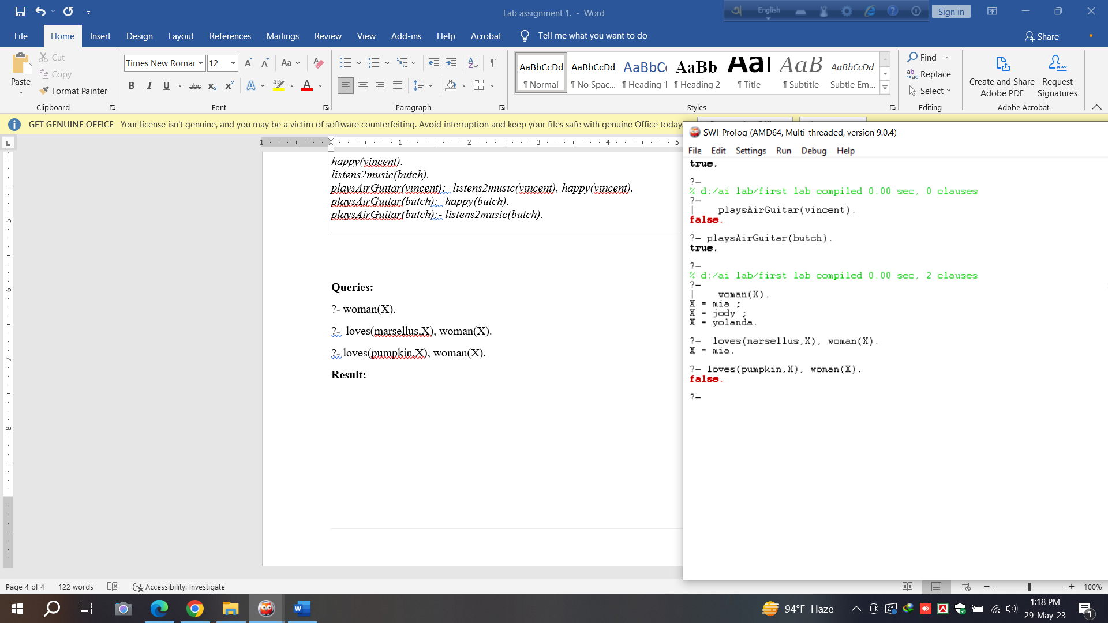

**Example 5:**

Knowledge Base 5.

**Clause:**

*loves(vincent,mia).*

*loves(marsellus,mia).*

*loves(pumpkin, honey_bunny).*

*loves(honey_bunny, pumpkin).*

*jealous(X,Y):- loves(X,Z), loves(Y,Z).*

**Queries:**

?- jealous(marsellus,W).

**Result:**

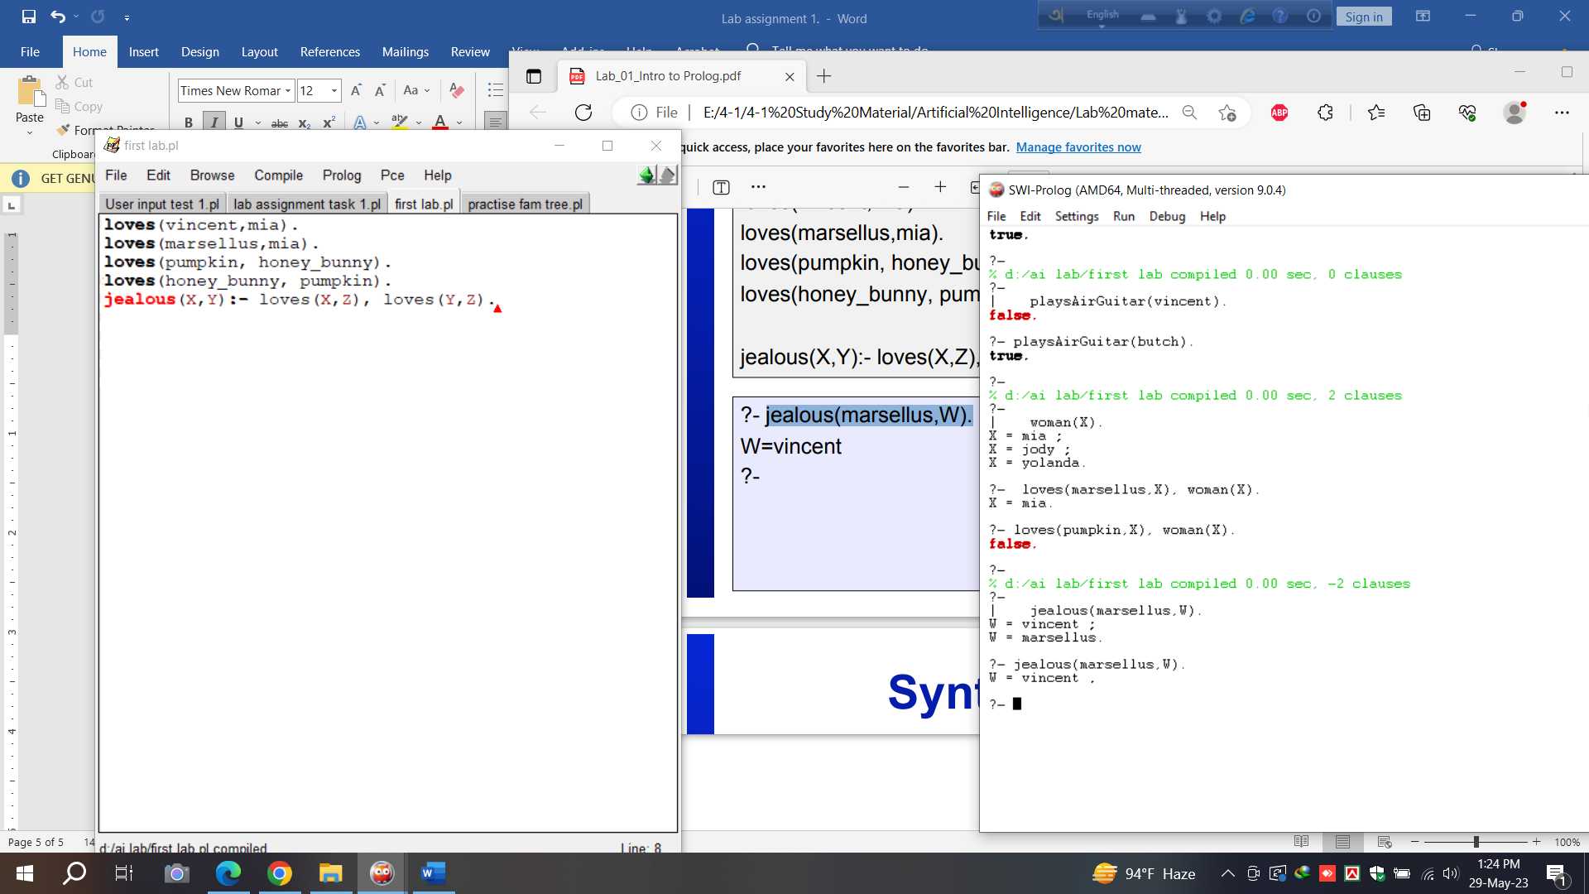

**Example 6:**

Exercise 1: Read & write two numbers

**Clause:**

*start:-*

*write('enter your first num'),nl,*

*read(X),nl,*

*write('enter your second num'),nl,*

*read(Y),nl,*

*write('here is your numbers'),nl,*

*write(X),nl,*

*write(Y).*

**Queries:**

?- start.

**Result:**

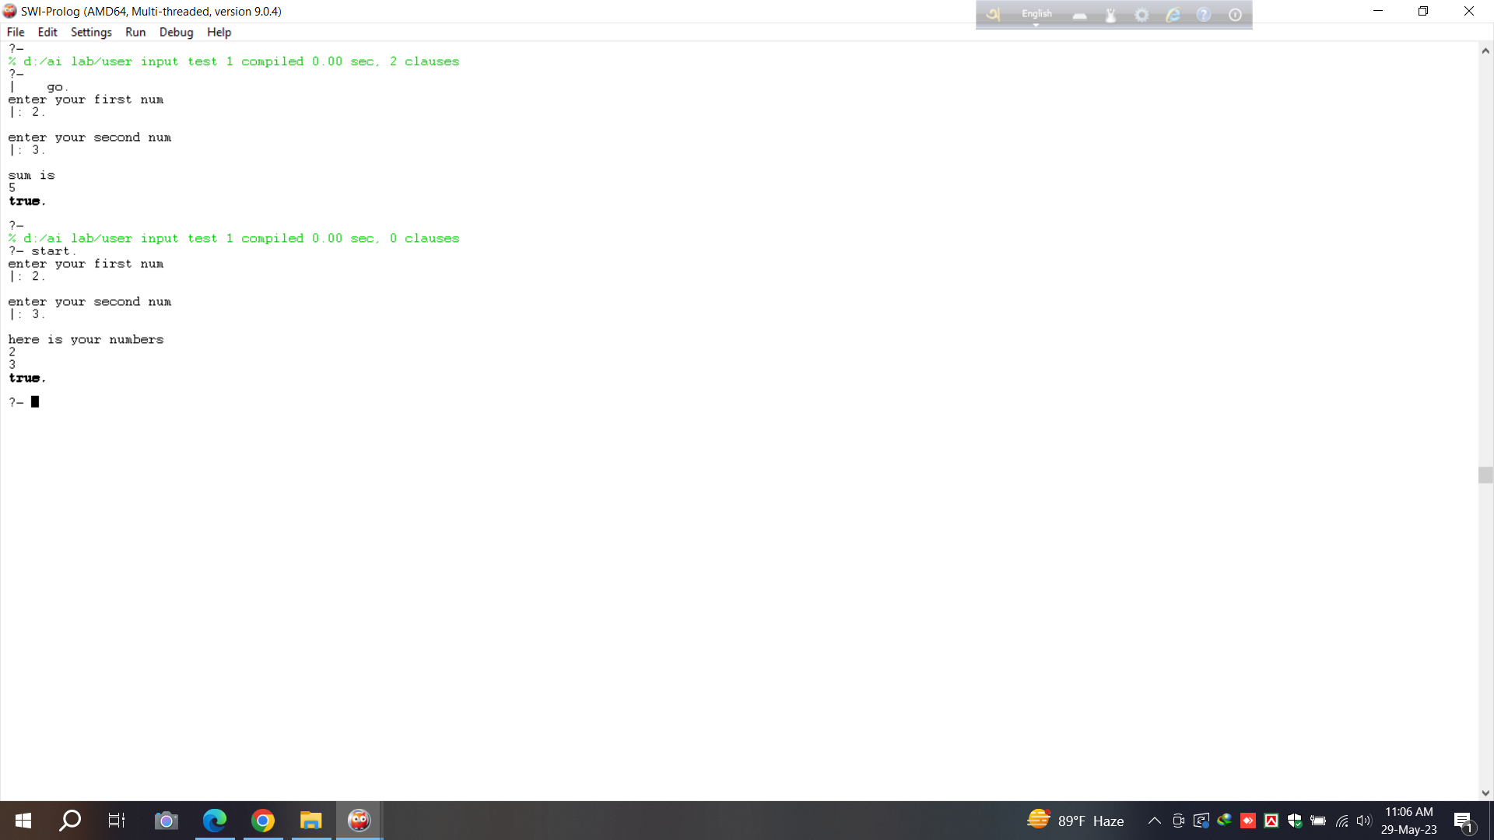

**Example 7:**

Exercise 2: Sum of two numbers

**Clause:**

*go:-*

*write('enter your first num'),nl,*

*read(X),nl,*

*write('enter your second num'),nl,*

*read(Y),nl,*

*sum(X,Y).*

*sum(X,Y):-S is (X+Y),*

*write('sum is'),nl,*

*write(S).*

**Queries:**

?- go.

**Result:**

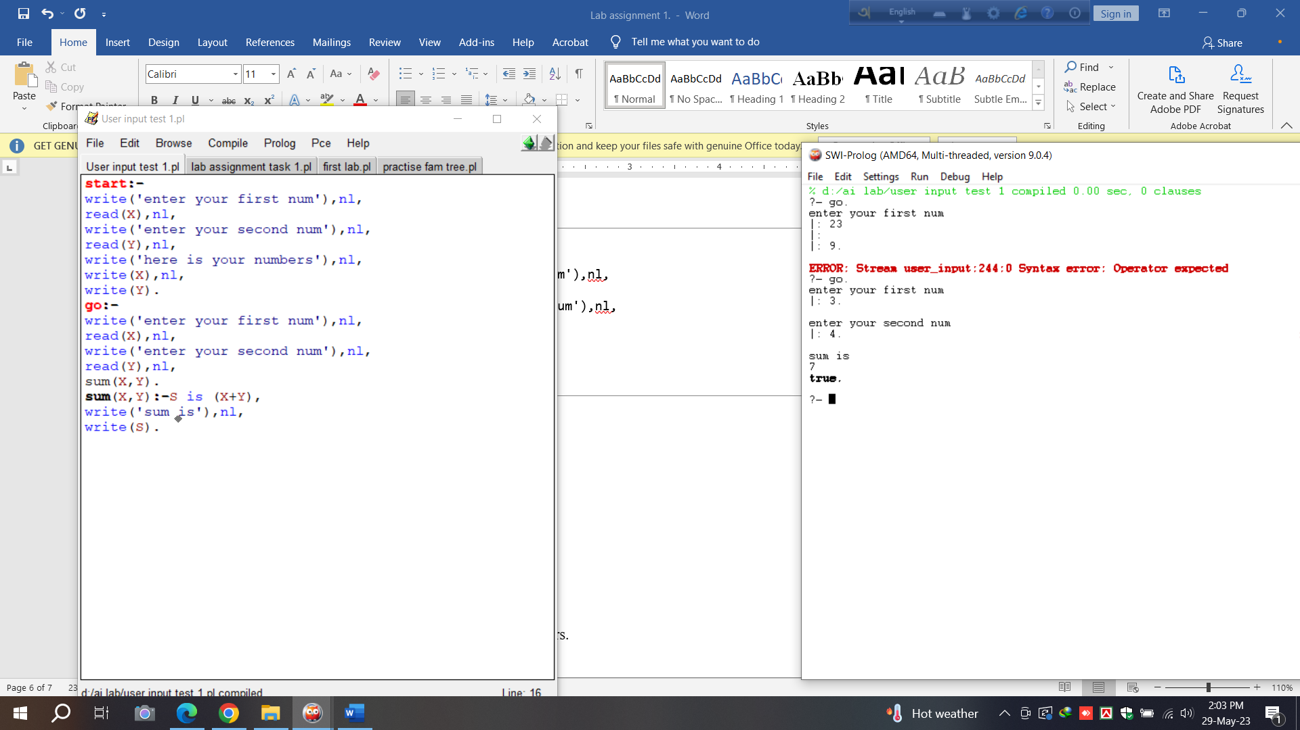

**Example 8:**

Task 1: Average of three numbers.

**Clause:**

*go:-*

*write('enter your first num'),nl,*

*read(X),nl,*

*write('enter your second num'),nl,*

*read(Y),nl,*

*write('enter your third num'),nl,*

*read(Z),nl,*

*sum(X,Y,Z).*

*sum(X,Y,Z):-S is ( X+Y+Z )/3,*

*write('average is'),nl,*

*write(S).*

**Queries:**

?- go.

**Result:**

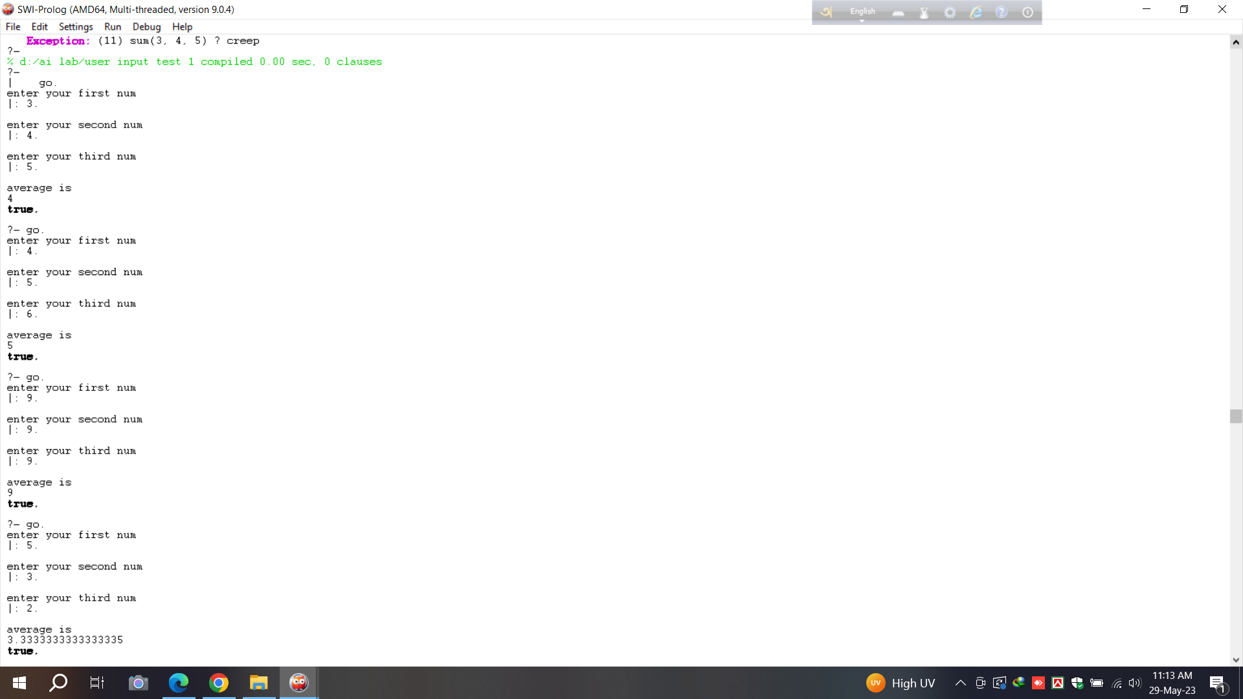

**Example 9:**

Task 2: Family Tree

**Clause:**

|  |
| --- |
| *ml(jamil).*  *ml(sohel).*  *ml(rafi).*  *ml(rumi).*  *ml(raj).*  *ml(orko).*  *ml(jarif).*  *ml(ovi).*  *femle(runa).*  *femle(riya).*  *femle(najia).*  *femle(ridima).*  *femle(sufi).*  *femle(saki).*  *parent(jamil,runa).*  *parent(jamil,sohel).*  *parent(runa,rafi).*  *parent(runa,rumi).*  *parent(runa,riya).*  *parent(sohel,najia).*  *parent(sohel,ridima).*  *parent(rafi,raj).*  *parent(rumi,sufi).*  *parent(najia,saki).*  *parent(najia,orko).*  *parent(sufi,jarif).*  *parent(orko,ovi).*  *siblings(X,Y):- parent(Z,X),parent(Z,Y),X\=Y.*  *moter(X,Y):-parent(X,Y),femle(X).* |

**Queries:**

?- ml(runa).

?- ml(sohel).

?- ml(jarif).

?- femle(sufi).

?- femle(ridima).

?- parent(jamil,_).

?- parent(sufi,_).

?- parent(saki,_).

?- parent(rumi,_).

?- parent(runa,X).

?- parent(jamil,X).

?- siblings(rafi,X).

?- siblings(najia,X).

?- moter(X,riya).

?- moter(X,orko).

**Result:**

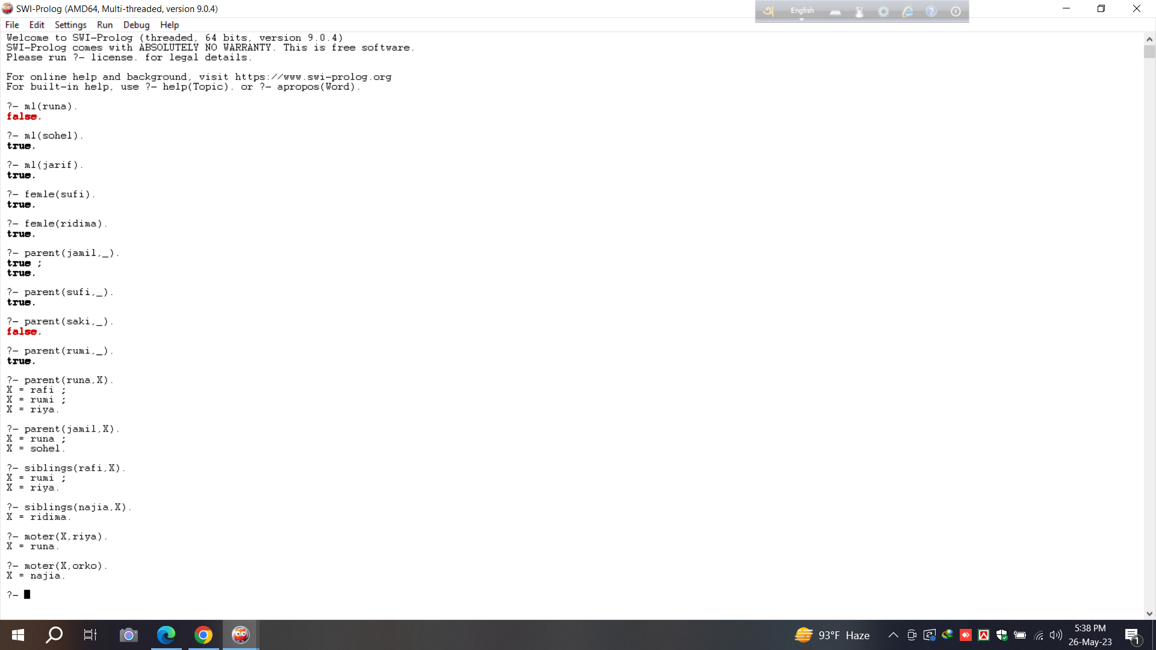

# Example 10:

**Problem Name :** Addition/Subtraction/Multiplication/Division/Power

**Queries :**

1) A is 1023+34+98.

2) S is 64-89

3) M is 78*54.

4) D is 67/34.

**Results:**

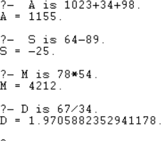

# Example 11:

**Problem Name:** Min/Max **Queries:**

MAXIMUM is max(23,-9).

1. MAXIMUM is max(-23,-9).
2. MINIMUM is min(2014,2450).

**Result:**

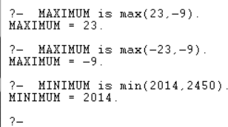

# Example 12:

**Problem Name :**Underscore **Clause :**

division(dhaka,rajshahi,khulna).

**Queries:**

1. division(X,Y,Z).
2. division(_,_,Z).

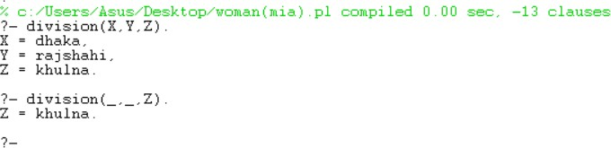**Result:**